Biosensors Package
User Manual
Version 2.2.0
Sébastien Besson, Chuangang Ren, Hunter Elliott, Andrew R. Jamieson

Contents
Overview 2
General description 2
Work flow of Biosensors Package: 2
Features 3
User manual 4
Step 1 – Acquire Your Data! 4
Step 2 – Software Installation 5
Step 3 - Preparing Your Data 5
Step 4 - Selecting Movies to Process 6
Movie panel 6
Package panel 6
Movie Creation 7
Data Preparation 8
Step 5 – Process the Movie(s) 9
Advanced tools 11
Alignment/Registration Transform Creation 11
Bleedthrough Coefficient Calculation 11

Overview

General description

This software is designed to process raw images from fluorescent biosensors into fully-corrected quantitative activation maps (ratio images). It assumes the images are standard 2D (widefield or single z-slice) fluorescence images of a ratiometric biosensor. Ratiometric biosensors use two image channels to determine the activity of interest: One channel is independent of the activity and gives the localization of the sensor, while the other varies in intensity with the activity the probe is designed to sense. These are referred to here as the ‘localization’ and ‘activation’ channels respectively. The localization channel is required when biosensors are imaged this way to separate variations in the concentration of the probe from variations in its measured activity. Because the comparison of the activation and localization channels is used to determine the magnitude and localization of the activity of interest, any difference between these two channels will be interpreted as a change in activation. Therefore, to ensure accurate measurement of activation, all other systematic differences between the channels must be eliminated. This requires several corrections to be applied to the images, which are described in more detail later on. When all corrections are applied and the activation and localization channels are ratioed, the result is a quantitative ‘ratio image’ of the location and magnitude of the activity of interest.

Work flow of Biosensors Package:

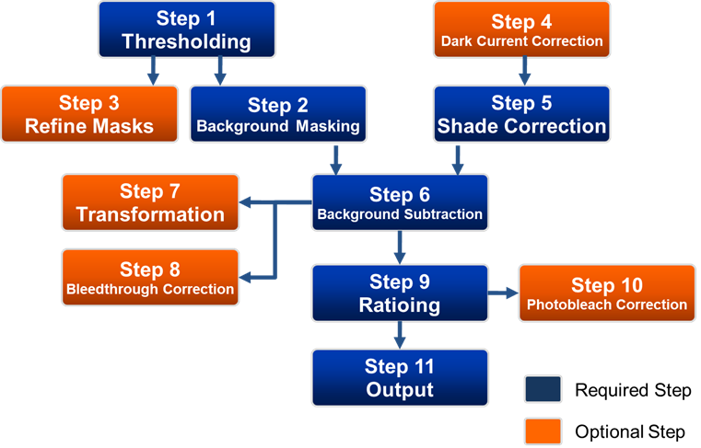
Figure 1: Biosensors Package Workflow

Features

Version 2.2.0 (May, 2015)
- Add support for graphics under MATLAB R2014b and above
- Fix various bugs (image transformation, bleedthrough correction)
- Improve error handling in image correction settings interface

Version 2.1.0 (June 18, 2013)
- Added support for movie relocation
- Implemented a graphical interface for preparing data
- Added a preview option when manually thresholding channels
- Added graphical interfaces for the transformation creation and bleedthrough coefficients calculation
- Included the ratio movie creation within the output process
- Fixed various bugs (correction images display…)

Version 2.0.0 (December 9, 2010)
- Process multiple movies at once, using the same settings and correction images
- Save groups of movies as “movie lists” for later re-processing, analysis with other software etc.
- Improved visualization of the results of each processing step.
- New tools for preparing your data for processing
- New tool for creating .avi or .mov movies from ratio images

User manual
The following is a step-by-step guide to using the software:

Step 1 – Acquire Your Data!

Experimental Data:

Depending on the type of biosensor, different data will be required for processing. For unimolecular biosensors you will need only images of the activation signal and localization signal in each experiment, in addition to the correction images described below. For bimolecular biosensors, you may need additional images to correct for bleedthrough into the activation channel.

Correction Images:

To produce accurate, quantitative activation ratio images, several corrections are required. These corrections must be specific to the imaging system used to collect the raw data, and therefore require collection of “correction images.” These include:

- Dark-current images for each camera used.
These are images taken with the same exposure time but with no light incident on the CCD. This gives a measure of the magnitude and spatial variation of the camera’s noise.

- Shade/Illumination correction images for each channel imaged.
These are images taken with the same illumination, filters, exposure etc. as the experimental data, but taken of a blank area of a coverslip, without any objects.

- Alignment images (usually only for dual-camera/multi-camera experiments).
These are images taken of static objects which can be imaged at every wavelength, such as multi-spectral beads or a grid micrometer. These are used to determine the alignment between the different cameras so the images may be registered.

- Bleedthrough Images (usually only for bimolecular biosensors).
Because both molecules of the biosensor rarely have identical localization within the cell, cross-talk or ‘bleed through’ between the various channels imaged must be accounted for. These are images taken of cells with only one half of the biosensor present, but imaged in both channels. This allows determination of a “bleedthrough coefficient” which can then be used to correct for the bleedthrough.

Step 2 – Software Installation

NOTE: This software requires Matlab 2010b or later. It has been tested on Windows 7, OS X 10.10 and Linux, and may have problems on other operating systems.

- Download the code .zip file from http://lccb.hms.harvard.edu/software.html
- Extract all the files from the .zip file you downloaded into a sub-directory of the default Matlab directory (the directory Matlab starts in when opened).
- Add this directory to the Matlab path. This can be done by going to File->Set Path... then click on "Add Folder..." and select the folder you extracted all the files to in step 1.

The software requires the following Matlab toolboxes:
- Image Processing Toolbox
- Statistics Toolbox
- Curve fitting toolbox

If automatic thresholding is not used, then only the Image Processing and Statistics toolboxes are required.

The error messages produced by the software are designed to be user-friendly. Please read the entire error message, as it may allow you to fix the problem yourself.
If you have any questions, error reports or suggestions to help us improve this software, please send an email to: andrew.jamieson@utsouthwestern.edu. We look forward to your feedback.

Step 3 - Preparing Your Data

The software requires that the image files for each channel of each movie (e.g. CFP, FRET, Phase, etc.) be stored in a separate directory, with one file per frame (timepoint) of the movie. That is, it should look something like this:

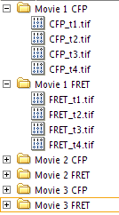
Figure 2: Data preparation format

If your data is not already in this format, don’t worry! We have included some simple tools to make it easy for you to automatically put your data in this format (see the Data Preparation section).

Step 4 - Selecting Movies to Process

Before you can begin processing your data, you need to tell the software where the data is. This is done using the “Movie Selector.” To start, either type “movieSelectorGUI” or “biosensorsPackageGUI” at the Matlab command line. The movie selector should open in a new window (Fig. 3).

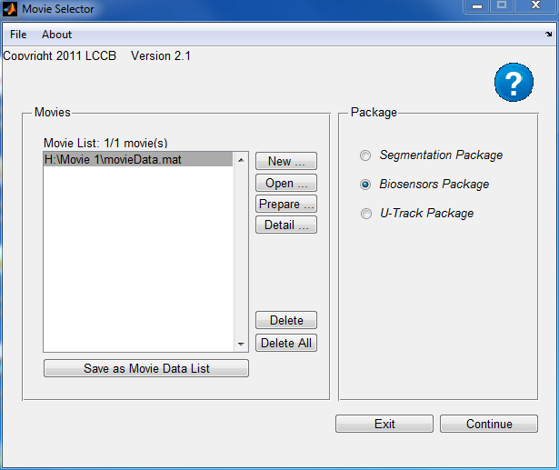
Figure 3: Movie selector
The movie selector contains two panels: the left panel concerns the movie selection/edition and the right panel deals with the package selection.

Movie panel
If this is the first time you have selected this movie, you will have to specify the directories containing the images for each channel of the movie. The locations of these directories, in addition to all the information regarding the processing of the movie, are stored in a file called the “movie data”. There are two ways of creating movies, either using the “New” button (see Movie Creation section) or using the “Prepare” button (see Data Preparation section).
If you have selected or processed this movie before, simply click the “Open” button and select the saved Movie Data or Movie Data List .mat file, then click “Ok”

Once the movies are selected, their directories will be displayed in the list box in Movie Selector Panel. By clicking “Save as Movie Data List” button; the current movies selected can be saved as a movie data list. The movie data list is saved in a MAT file. To load the same set of movies the next time, open the saved movie data list MAT file by clicking “Open” button. Note that movie data list only copies the directories of movie data instead of the movie data themselves.

Package panel
Select “Biosensors Package” from the package list, and click “Continue” to begin processing your data.

IMPORTANT NOTE: If more than one movie is to be processed at once, it is VERY IMPORTANT that the channels from all the movies be in THE SAME ORDER. That is, if movie One has Channel 1 as FRET, Channel 2 as CFP and Channel 3 as YFP, then movie 2 must also have these same channels in the same order.

Movie Creation
If this is the first time you have processed this movie, you will need to create a movie data file for it:
- Click the “New” button to create new “movie data” (Figure 3: Movie selector). The movie creation window should pop-pup:

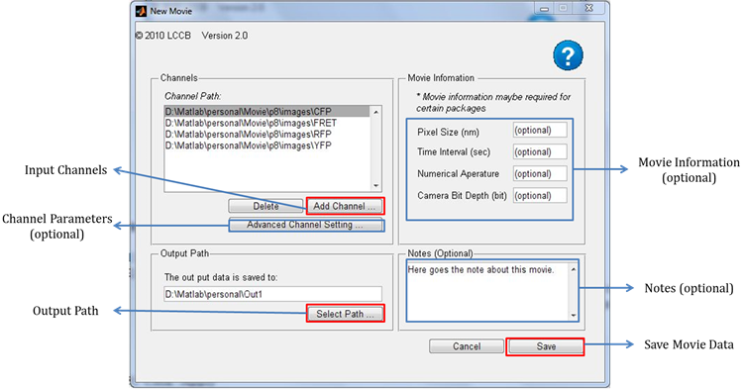
Figure 4: New movie creation
- Define the required (and/or optional) parameters:

- Input channels: here you can select folders containing the images for each channel of the movie. Each channel must be in a separate folder, with one file per time point (see Step 3 - Preparing Your Data) Note that all channels should have the same number of images, and their images should all be the same size.

- Output Path: this specifies where the results of the processing will be stored.

- Channel-specific Parameters (optional): excitation wavelength, emission wavelength, exposure time. These parameters are not used by this package, but can be specified.

- Movie Information (optional): pixel size, time interval, numerical aperature, camera bit depth. These parameters are not used by this package, but can be specified.

- Notes (optional): a note describing the condition, experiment number, the date, etc. - anything you want!

- Click “Save” to save your settings as a MAT file.

Data Preparation
If you want to prepare a batch of unsorted image series, you can use the data preparation tool. Note: this tool does not work if your channel images are already separated in separate folders.

- Select “Prepare” from the movie selector (Figure 3: Movie selector): the data preparation window should pop-pup:

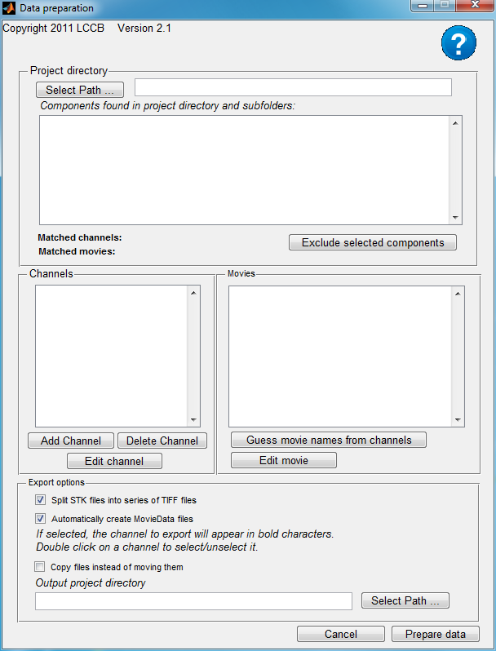
Figure 5: Data preparation interface
- Click the “Select path” button to select the main folder containing your raw data. All components found in the main folder and its subfolders should appear in the listbox underneath. If the movies are already organized into separate folders, a list of movies should appear in the corresponding list box.

- Click the “Add channel” button to create a new channel. An editable window will pop-up allowing you to edit the channel string and other channel properties. Once you’ve entered the information the matching components will be appear in bold

- Optional – If your data is not organized into separate movie folders, once you’ve set up all channels (i.e. once every component has been associated with a channel), click on the “Guess movie names from channels” pushbutton.

- Once all components are associated with a channel and a movie, select the appropriate options from the export panel and click on “Prepare data”. Do not forget to check “Automatically create MovieData files“ if you want to process these movies.

Step 5 – Process the Movie(s)

You should now see a panel which looks something like this:

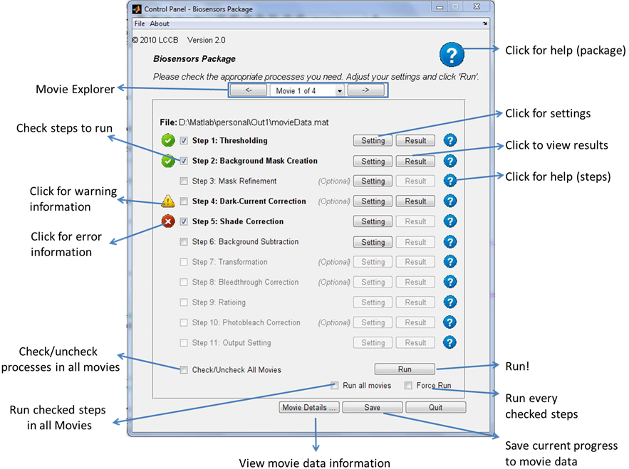
Figure 6: Biosensors Package Control Panel
You must now set up and run each step of the processing. If you are processing more than one movie, you may configure the settings on only the first movie and then run all movies with these settings. However, you are required to configure the settings for each step on at least the first movie. To run the processing steps:

- Select checkboxes of the steps you would like to run. A step that depends on other step(s) cannot be selected until the step(s) on which it depends have been selected (see Figure 1: Biosensors Package Workflow).

- Configure the selected steps before running by clicking the "Setting" button next to the step, and then clicking “Apply” in setting panel.

- Click “Run” - By default this will run all selected steps which have NOT yet been successfully run in only the current movie. Additionally, you may check these boxes:
- “Force Run” checkbox - Re-run the steps which have been successfully run.
- “Run all movies” - Run all checked steps in all movies (if more than 1 movie is loaded)

- When a step has been completed, click the corresponding "Result" button to display the results of that step.

Indicator icons will appear next to steps once they have been run/attempted to be run:

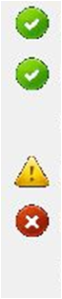

The step has been processed successfully.

There is a warning regarding this step. Click the icon for more information.

There was an error and the step was not completed. Click the icon for more information.

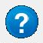
Help Icons can be found throughout the software. Click on these icons to see help for the GUI as a whole, individual steps, and the settings for individual steps.

When you complete the final step, “Output” the fully-corrected ratio images will be saved to a directory as .tif image files, which can then be analyzed and displayed with other software. Because .tif files only store integer-valued images, the ratio images must be multiplied by a “scale-factor” first. It is important to use a consistent scale factor when comparing multiple images/experiments.
Additionally, you can create .mov or .avi movies of the final ratio images for use in presentation, supplementary material…

Advanced tools

These tools can be selected using the Tools menu of the main control panel (see Figure 6: Biosensors Package Control Panel)

Alignment/Registration Transform Creation

Producing accurate ratio images requires that the images being ratioed are very well aligned, or “registered.” Misalignment is very significant when multiple cameras are used to acquire the different images, but can still be significant in single-camera applications. To align images from different channels, this software allows application of an “image transform.” However, the transformation must be determined beforehand. This is accomplished by taking registration images and then determining a transform from them.

Registration images are images of the same object taken in multiple channels. This is usually multi-spectral fluorescent beads, or a grid micrometer. Other images can be used, but is important to be sure that the only difference between what’s imaged in each channel is the alignment. For this reason, experimental images (eg images of cells, single-molecule FRET probes etc) are generally not acceptable.

Once the registration images have been taken, select Tools > Alignment/Registration Transform Creation from the control panel to create and save a transform. This transform can then be used in the biosensors package to align the two channels the registration images came from. For more than two channels, multiple transforms may be needed.

Bleedthrough Coefficient Calculation

When ratiometric biosensors are imaged, there is almost always some bleedthrough between the different channels. That is, the fluorescence in one channel shows up in the other channel, but to a lesser extent. With unimolecular biosensors, the two channels are perfectly co-localized, so the ratioing itself ‘cancels out’ the bleedthrough. With bi-molecular biosensors or with single-molecule imaging, the localization is rarely identical and therefore the bleedthrough must be corrected. However, before it can be corrected, bleedthrough coefficients must be determined, which describe the extent to which one channel bleeds into the other.

Bleedthrough coefficients can be determined by imaging only one of the two fluorophores in both channels. For example, to determine CFP to FRET bleedthrough, you would image only the CFP part of the biosensor, but you would take images in both the CFP and FRET channels.

Once the bleedthrough images have been taken, create a normal biosensors movie for processing (see “Data Preparation” above). Then process this movie through all initial steps until “Background Substraction”. Finally select Tools > Bleedthrough Coefficient Calculation from the control panel to calculate the bleedthrough coefficient for the sets of channels that were imaged.

